**4. ReactJS-HOL-Documentation**

**Objective :**

* Implement componentDidMount() hook
* Implementing componentDidCatch() life cycle hook.

**Prerequisties :**

The following is required to complete this hands-on lab:

* Node.js
* NPM
* Visual Studio Code

**Project Folder Name :**

* blogapp

**Procedure :**

(Follow up the steps given in hands on)

**Output Snapshot :**

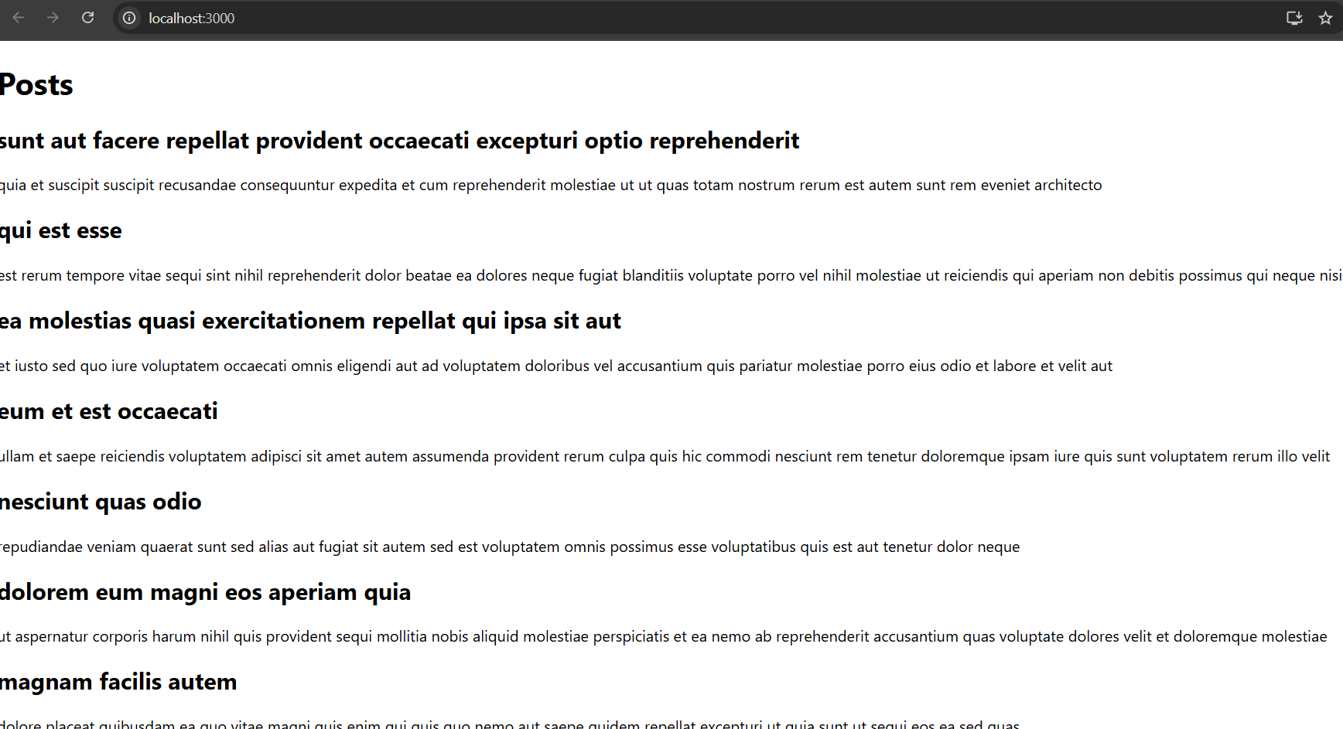

**Knowledge Gain :**

Ques. Explain the need and Benefits of component life cycle?

React’s lifecycle methods help you control the flow of your app, offering advantages like:

* Timing control: Run code at specific points (e.g., when the component appears, updates, or disappears).
* Performance optimization: Load data efficiently, cancel subscriptions, or prevent unnecessary re-renders.
* Resource management: Clean up tasks like timers, network requests, and event listeners.
* Debugging and testing: Hook into key stages for better monitoring.

Ques. Identify various life cycle hook methods?

In Class Components

| Stage | Lifecycle Method | Purpose |
| --- | --- | --- |
| Mounting | constructor() | Initialize state and bind methods |
|  | componentDidMount() | Run code after initial render (e.g., API call) |
| Updating | shouldComponentUpdate() | Control whether the component should re-render |
|  | componentDidUpdate() | React to state/prop changes |
| Unmounting | componentWillUnmount() | Cleanup tasks (e.g., timers, subscriptions) |

In Function Components (with Hooks)

| Hook | Equivalent to | Purpose |
| --- | --- | --- |
| useEffect() | componentDidMount, DidUpdate, and WillUnmount | Multi-use lifecycle control (based on dependencies) |
| useLayoutEffect() | Runs synchronously after DOM updates | Useful for layout calculations or measurements |

Ques. List the sequence of steps in rendering a component?

1. Initialization
   * Constructor runs
   * State and props are initialized
2. Mounting
   * render() is called
   * Component mounts to DOM
   * componentDidMount() runs
3. Updating (when state or props change)
   * shouldComponentUpdate() decides if render should happen
   * If yes: render() runs again
   * Then: componentDidUpdate() executes
4. Unmounting

* componentWillUnmount() runs to clean up